**Introduction:**

**Unveiling Market Insights**

* Simply put, a market insight is the discovery of a relevant, actionable and previously unrealized reality about a target market as the result of deep, subjective **data analysis**. The goal of insight in marketing — especially when marketing a previously unused or unknown innovation — is to benefit both parties, meeting your target audience’s true needs and wants while simultaneously profiting. In other words, the **best market insights** offer value for both the seller and the companies in need of the innovation.

Purpose:

* The goal of the field of market isights is to learn about and analyse the market.Data on the market ,cosumers,and competitiors must be gathered,analysed,and interpreted by individuals in this role.

Problem Definition & Design Thinking:

Empathy Map

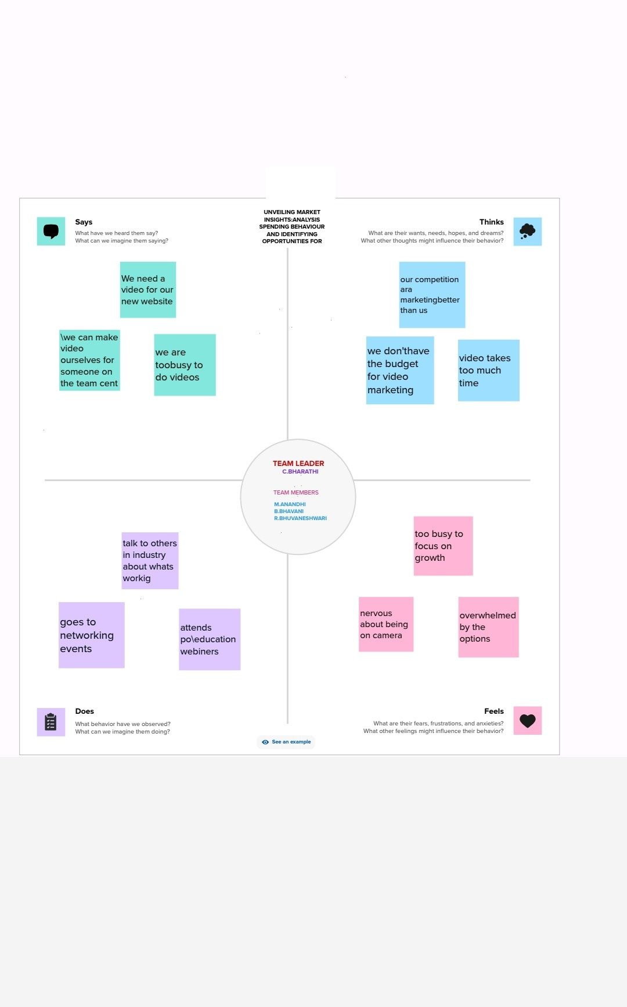

BRAINSTORM:

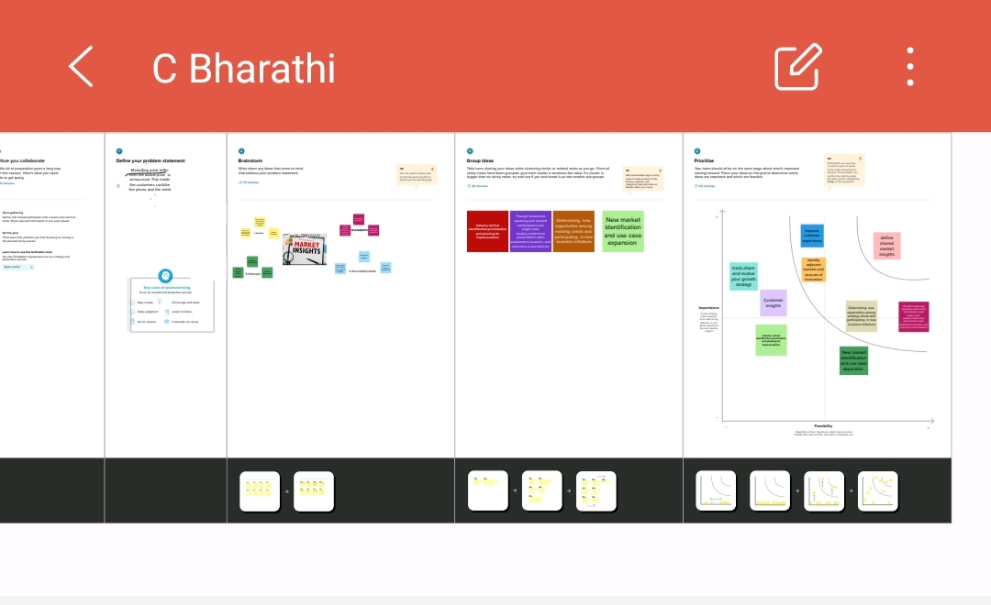

Result

Data Model:

|  |  |
| --- | --- |
| Object Name | Fields In The Object |
| KPI’s | |  |  | | --- | --- | | Field Label | Data Type | | Milk | Number | | Grocery | Number | | Fresh | Number | |
| Channel Wise Frozen,Delicates | |  |  |  | | --- | --- | --- | | Field Label | Data Type | | | Channel | Number | | | Detergent Paper | Number |  | |
| Region Wise Detergent Paper,Grocery | |  |  | | --- | --- | | Field Label | Data Type | | Region | Number | | Grocery | Number | |
| Region Wise Delicatessen,Detergent Paper | |  |  | | --- | --- | | Field Label | Data Type | | Channel | Number | | Delicatessen | Number | |
| Channel Wise Grocrery ,Detergent Paper | |  |  | | --- | --- | | Field Label | Data Type | | Region |  | | Detergent Paper |  | |
| Region Wise Milk | |  |  | | --- | --- | | Field Label | Data Type | | Region | Number | | Milk | Percentage | |
| Channel Wise Grocery,Detergent Paper | |  |  | | --- | --- | | Field Label | Data Type | | Region | Number | | Detergent Paper | Number | |

Activity ad Screenshot:

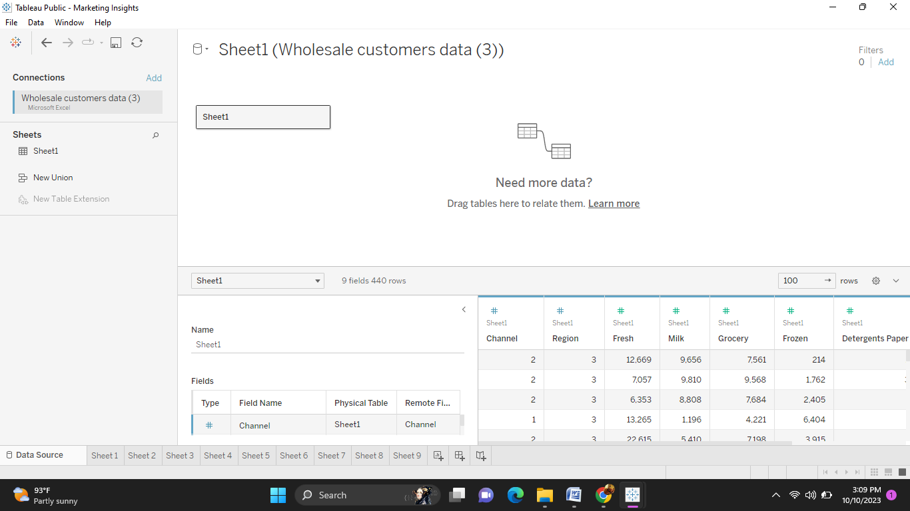

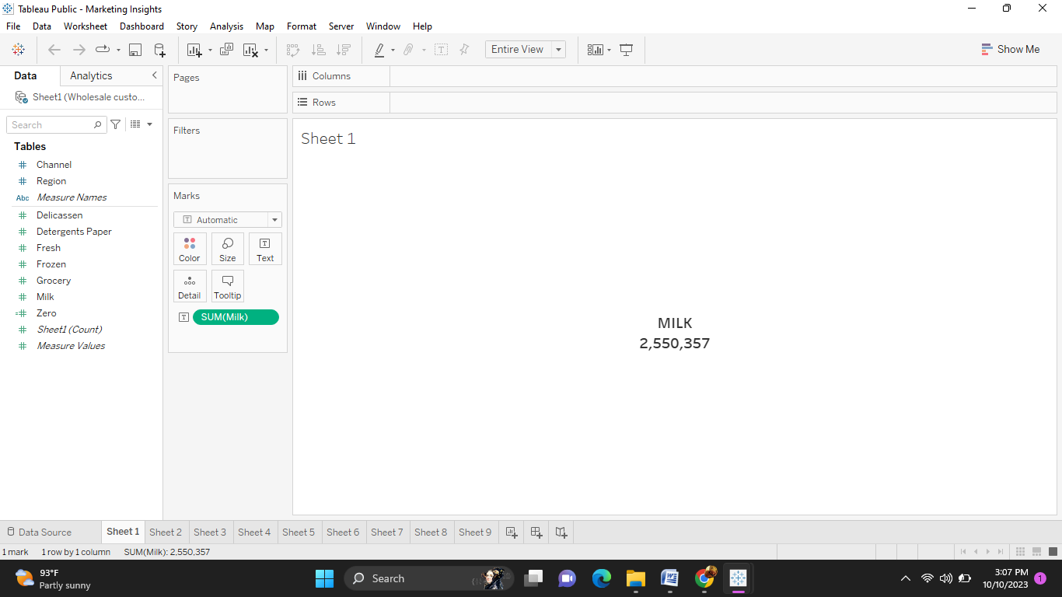

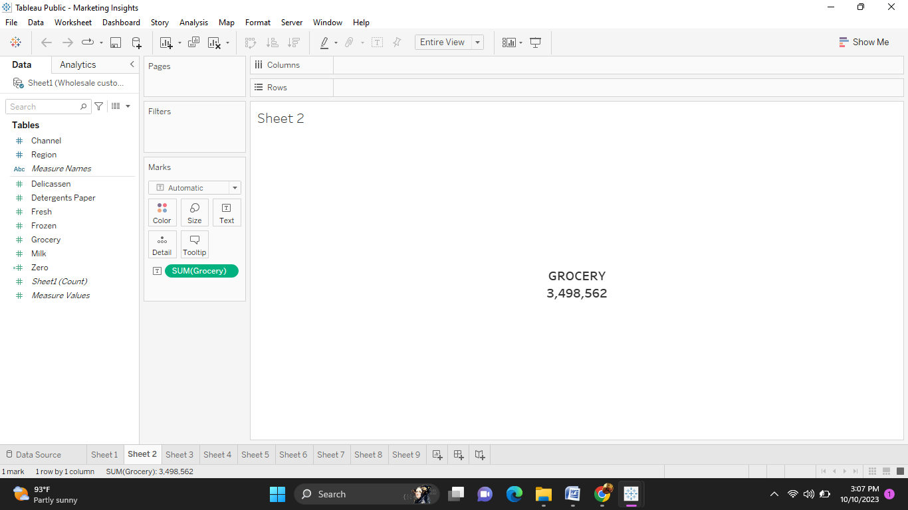

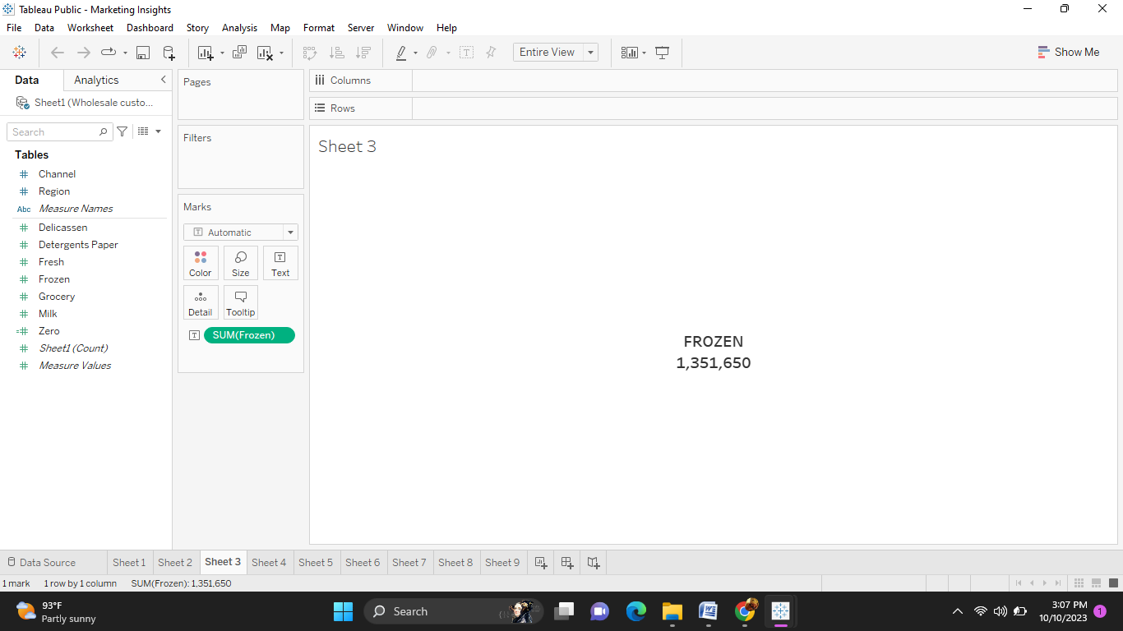

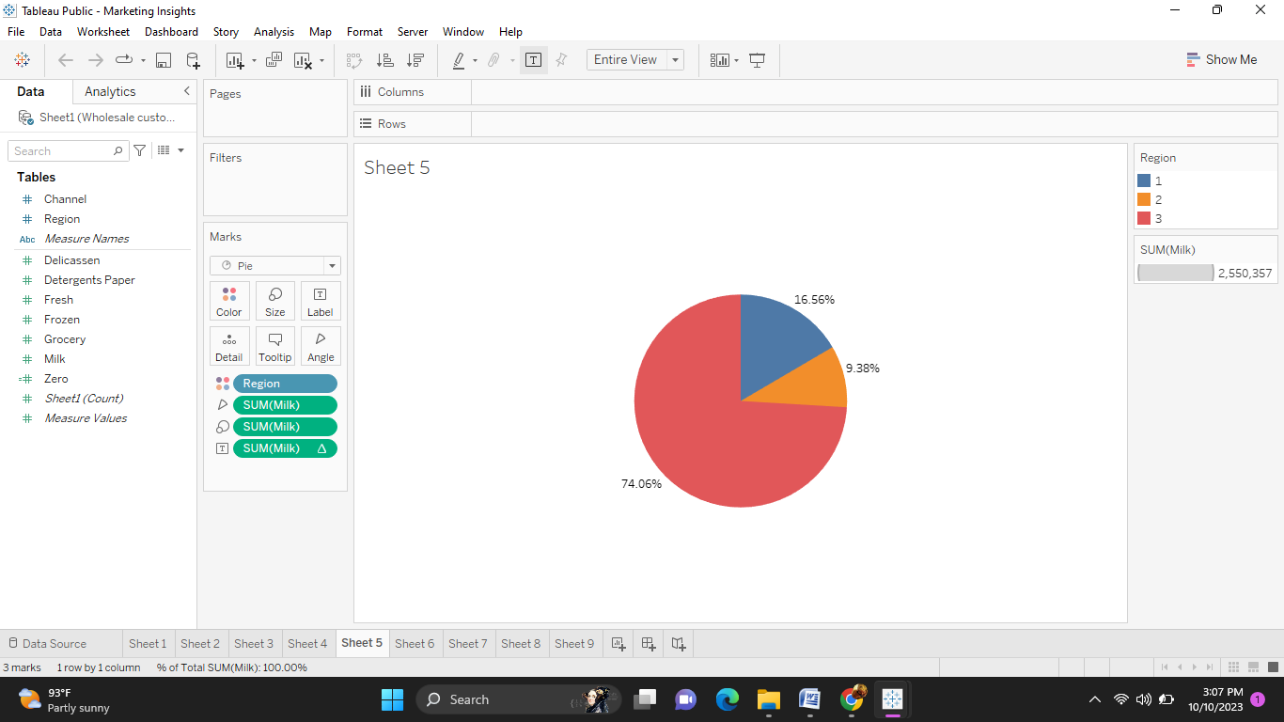

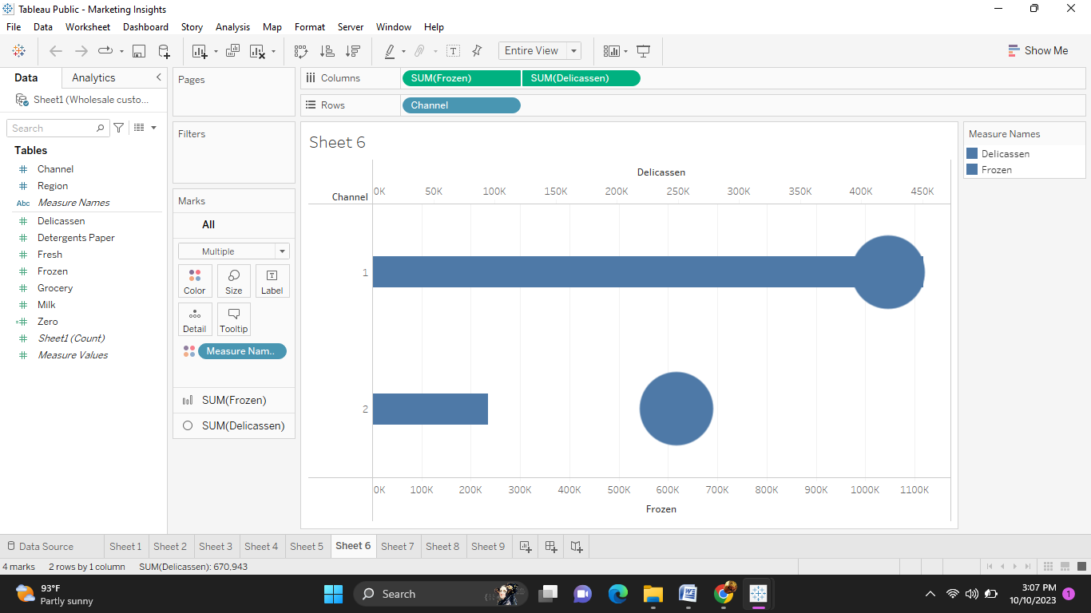

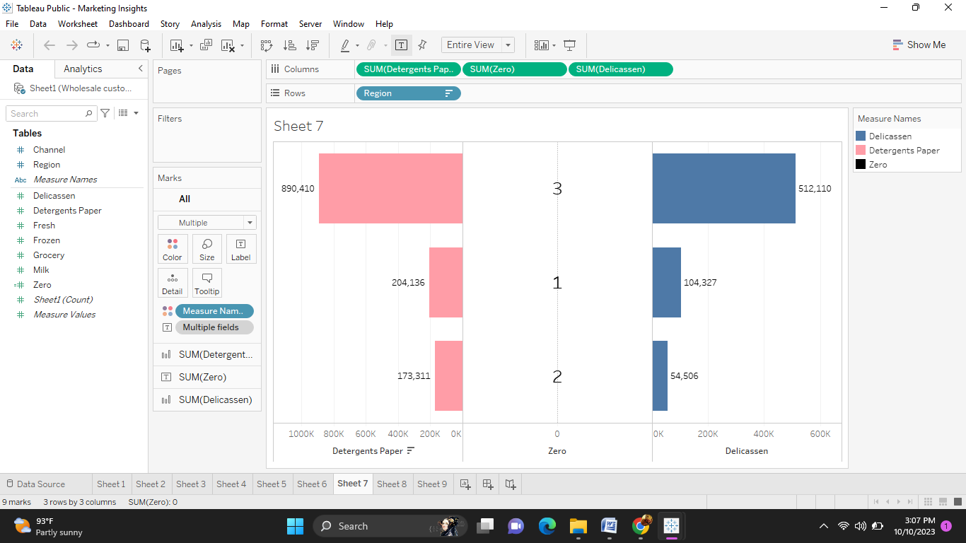

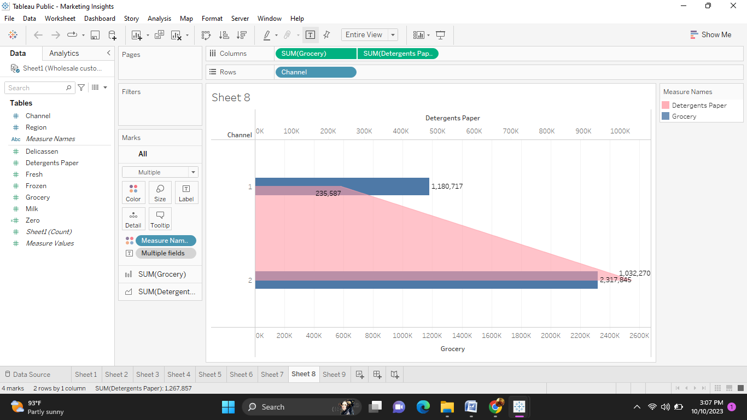

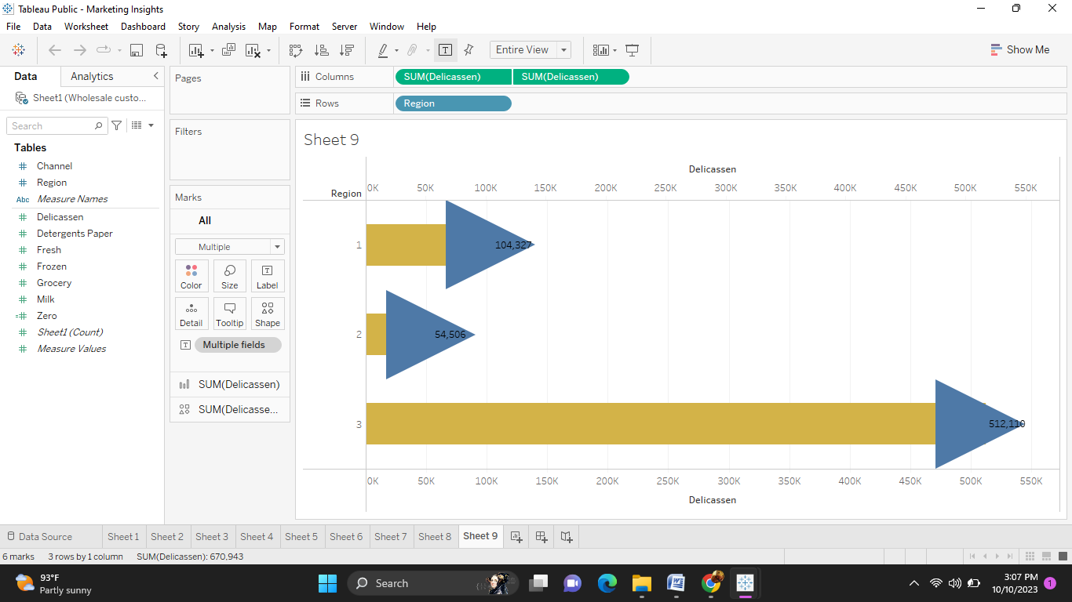

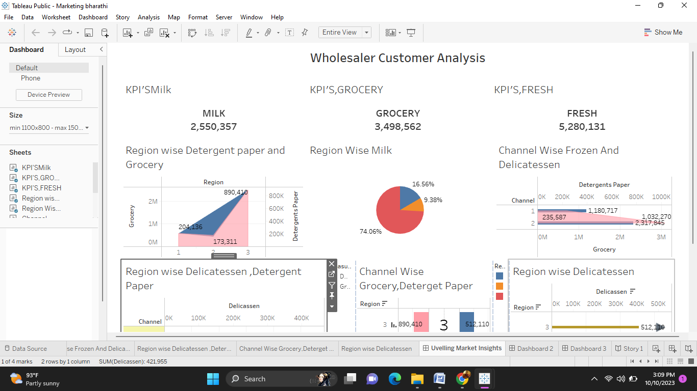

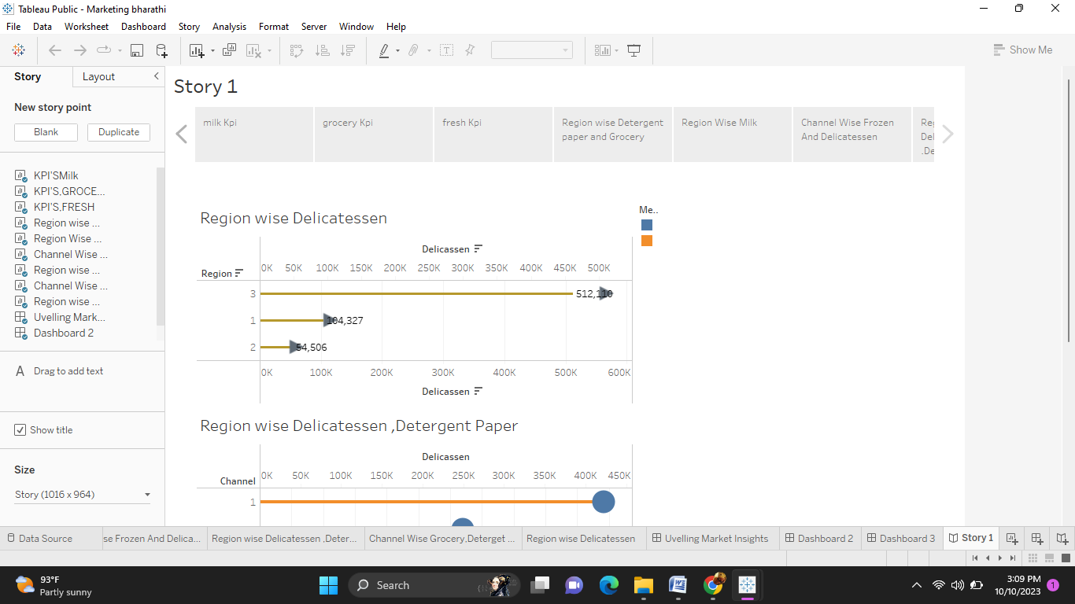

4,Trailhead profile public URL:

Team Lead- https://public.tableau.com/app/profile/bharathi.c2980/vizzes

Project Report Template

5 ADVANTAGES ^&DISADVANTAGES:

ADVANTAGES:

* Promotes Your Business to a target Audience.

* Helps You Understand Your Customers.

DISADVANTAGES:

* Helps Brand Your Business.

* Costs Of Marketing.

* Time and Effort May Not yield a return.

Applications:

Marketing Application means an application for marketing authorization which has not yet been approved by the FDA or other Regulatory Authority, including without limitation, FDA New Drug Application, FDA Abbreviated New Drug Application, and other similar marketing applications promulgated by Regulatory Authorities.

Conclusion:

we have tried to give you the details about marketing insight and its importance. One of the most important benefits of marketing insights we learned is that it will strengthen the relationship between marketers and customers by providing the details needed to solve marketing problems and assist with marketing policy.

Understanding customer behavior and attitudes are essential to developing effective marketing strategies.

If you need help conducting marketing insights research, contact the QuestionPro team of experts. QuestionPro can help you navigate the process and make the most of your data.

FUTURE SCOPE:

The future scope of marketing is increasing exponentially. It involves researching, planning, and coordinating. The growth of digital technologies and the Internet boom have positively impacted marketing scope. Much credit goes to digital marketing and social media marketing for contributing to the explosion of the marketing industry and immensely expanding the scope of marketing management.